1.import java.util.Scanner;
public class Ascending_Order
{
public static void main(String[] args)
{
int n, temp;
Scanner s = new Scanner(System.in);
System.out.println("Author :J.GOPI VENKATA SAI\n SAP ID:51834677");
System.out.print("Enter no. of elements you want in array:");
n = s.nextInt();
int a[] = new int[n];
System.out.println("Enter all the elements:");
for (int i = 0; i < n; i++)
{
a[i] = s.nextInt();
}
for (int i = 0; i < n; i++)
{
for (int j = i + 1; j < n; j++)
{
if (a[i] > a[j])
{
temp = a[i];
a[i] = a[j];
a[j] = temp;
}
}
}
System.out.print("Ascending Order:");
for (int i = 0; i < n - 1; i++)
{
System.out.print(a[i] + ",");
}
System.out.print(a[n - 1]);
}
}

OUTPUT:
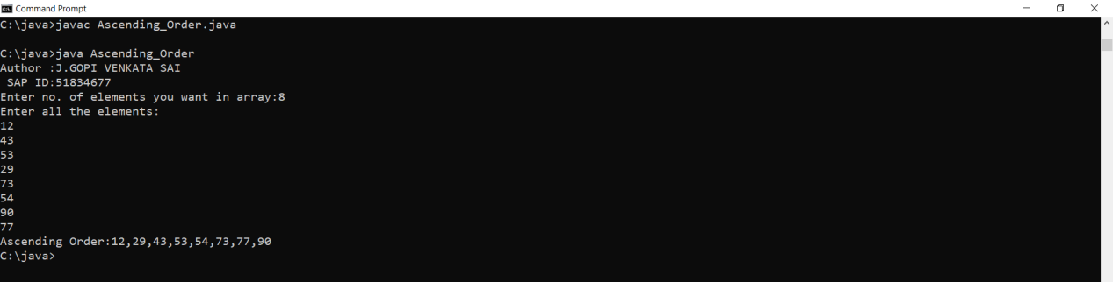

2.import java.util.Arrays;

public class Main
{
private static int[] mergeArray(int[] array1, int[] array2)
{
System.out.println("Author:J.GOPI VENKATA SAI\nSAP ID:51834677");
int[] mergedArray = new int[array1.length + array2.length];

int a=0, b=0, c=0;

while (a < array1.length)
{
mergedArray[c] = array1[a];
a++;
c++;
}

while (b < array2.length)
{
mergedArray[c] = array2[b];
b++;
c++;
}

Arrays.sort(mergedArray);

return mergedArray;
}

public static void main(String[] args)
{
int[] array1 = new int[] {7,-3,46,-36,74,-36,93,-46,-10,40};

int[] array2 = new int[] {8,83,-36,94,-39,83,-45,98,-100,99};

int[] mergedArray = mergeArray(array1, array2);

System.out.println("Array 1 : "+Arrays.toString(array1));

System.out.println("Array 2 : "+Arrays.toString(array2));

System.out.println("Merged Array : "+Arrays.toString(mergedArray));
}
}

OUTPUT:
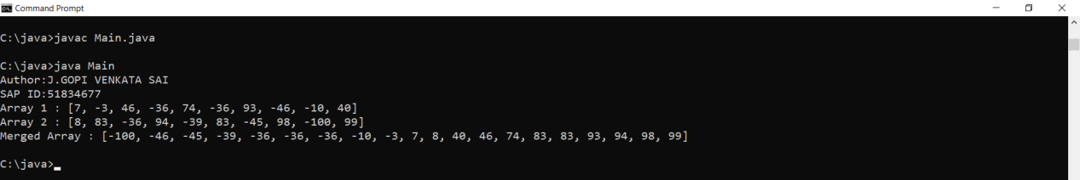

5.import java.util.Scanner;
public class WordCount {

public static void main(String[] args)
{
Scanner in = new Scanner(System.in);
System.out.print("Input the string: ");
String str = in.nextLine();
System.out.println("AUTHOR : J.GOPI VENKATA SAI\nSAP ID: 51834677");
System.out.print("Number of words in the string: " + count_Words(str)+"\n");
}

public static int count_Words(String str)
{
int count = 0;
if (!(" ".equals(str.substring(0, 1))) || !(" ".equals(str.substring(str.length() - 1))))
{
for (int i = 0; i < str.length(); i++)
{
if (str.charAt(i) == ' ')
{
count++;
}
}
count = count + 1;
}
return count; // returns 0 if string starts or ends with space " ".
}
}

OUTPUT:
